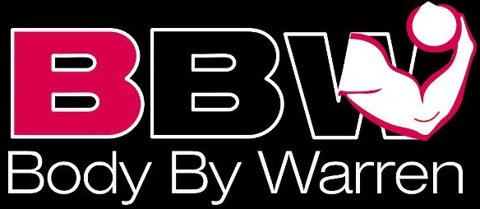

www.teambodybywarren.com
CONTACT INFORMATION: (please print clearly)
NAME: _________________________________________________
FULL ADDRESS: ________________________________________________
EMAIL: ___________________________________________________
PHONE: (best number) ____________________________________
BIRTH DATE: ______- _______- _______
HOW DID YOU HEAR ABOUT TEAM BBW? _____________________________
WEIGHT/HEIGHT: _____________________
GOALS (CIRCLE ALL THAT APPLY): FAT LOSS BUILD MUSCLE MAINTAIN

Non-competitor plan: (12 consecutive weeks) $650.00
Client agrees to pay in one of the following manners, outlined below:

UPON RELEASE OF THE PROGRAM, ALL SALES ARE FINAL. NO REFUNDS.
Payment Method: (circle one) **NO CHECKS**
- Venmo for $650.00 to Warren Fahrenfeld (TeamBBW)
- PayPal for $665.00 (which includes a $15.00 PayPal service fee) to bodybywarren@aol.com

Your individualized plan should not be used for diagnosing or treating health problems. Not all diet and exercise plans suit everyone. You should always consult your licensed healthcare provider before starting a diet, taking any form of supplement, or embarking on any fitness or weight training program. I am not a doctor. The information I provide is based on my personal experience through nutrition, coaching, and personal trainer. Any recommendations I make about weight training, nutrition, supplements or lifestyle should be discussed between you and your doctor.
Client Signature: ______________________________ Date: ____________
Food allergies, injuries, or weight lifting limitations: ________________________________________________
Foods you will NOT eat: ______________________________________________________________________
List of medications you are taking: ______________________________________________________________
How much cardio are you currently doing? #days/minutes/intensity: __________________________________
List of in-home weight training equipment if you will NOT be going to a gym: ___________________________
__________________________________________________________________________________________

If submitting via email, please include photos: front/side/back
LADIES- in a sports bra & shorts or bikini. MEN- shorts, no shirt.
Send this form and photos to BODYBYWARREN@AOL.COM if submitting via email.
This consecutive 12-week plan includes:
-Customized diet, cardio, and workout program, plus supplement recommendations.
-Weekly check-ins via email or bi weekly in-person.
-Unlimited support for questions between check-ins.
-Meal prep guidance and recipe ideas based on your plan.
-Diet and workouts/cardio are changed AS OR IF needed along the way.
You will be responsible for sending progress photos and a progress report each week,
or come weekly for in-person check-ins.
It’s up to you to stay on track and be in touch! We will not chase after you for your check-ins.

